
Year 11 APPLICATIONS UNIT 2
Investigation 3 2020
Task weighting 5.5%
Due: Thursday 29th October 2020
Name: _____________________________
Measuring What You Cannot See
Relevant syllabus content:
2.2.3  2.2.4 | Trigonometry – Non Right Angled Triangles  solve problems involving non-right-angled triangles using the sine rule (acute triangles only when determining the size of an angle) and the cosine rule  solve practical problems involving non-right-angled triangles, including problems involving angles of elevation and depression and the use of bearings in navigation

Complete the following set of questions by Thursday 29th October.
- You are not required to hand in your solutions. Solutions are provided on the last few pages for you to check your answers.
- Investigation test is on Thursday 29th October and will be based on the concepts considered in this investigation.
- The investigation mark is based solely on the investigation test [5.5% of your school based mark]

In this investigation, and investigation test you will need

- A ruler
- A protractor
- A compass

Surveying is an important area where trigonometry is utilised. It has many different techniques of mapping out land. There are two main techniques: Triangulation and the Radial Method.

Part A: Triangulation

Triangulation is the method involving the geometrical construction of triangles through the measure of distances and bearings between points.

Consider the situation given two points A and B. We can locate the position of C by either

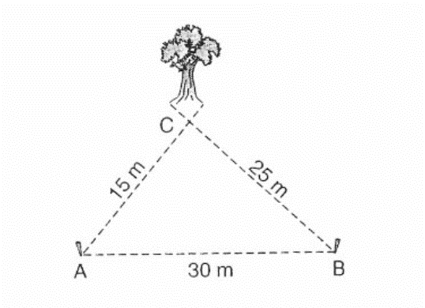
- Measuring the distance from A to C and the distance between B and C.
or
- Measuring the bearing of C from A and the bearing of C from B.

We call the line from A to B the survey line.

This method can be extended to locating positions several landmarks given a survey line AB.

Question One

A surveyor recorded the following information.

A survey line AB is 50m long and runs in a north – south direction. A compass is used to measure the angles between the base line and the stations P, Q, R and S. These are given in the table.

Station | Bearing from A | Bearing from B
P | 110° | 034°
Q | 148° | 068°
R | 191° | 225°
S | 290° | 333°

- Draw a scale drawing using the surveyor’s recordings. Use the scale 1mm : 1m.
- Use trigonometry to determine the length of SR and QR.

Part B: The Radial Method

The radial method uses the following method for surveying a field.
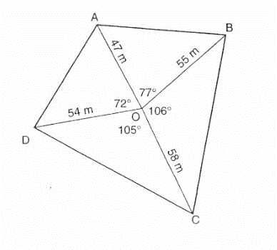
- Choose a point, O, somewhere inside the field
- From point O, determine the bearing of each corner and the distance from point O to each corner.
- Draw a diagram as shown.

Question Two

The sketch below is the result of a radial survey of a field.

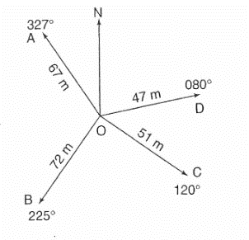

- Use this sketch to make an accurate scale diagram.
- Use trigonometry to calculate the perimeter and area of the field.

Question Three

The information in the table below is the result of a radial survey.

Station | Bearing from O | Distance from O
A | 030° | 48 m
B | 090° | 56 m
C | 220° | 37 m
D | 330° | 58 m

Make a sketch of the field and then use trigonometry to find the perimeter and area.

SOLUTIONS – For all diagrams check with your friends and teacher.

- SR = 75.91m, QR = 43.13m
- P = 335.91, A = 6352.45m²
- P = 269.58m, A = 4171.56 m²

